Civil war in Sierra Leone

UNSC Resolution: | 1400
Date of adoption: | 28 March 2002
Operative paragraph: | 4
Demand number: | 1

Megan MacKenzie

Wording of demand

strengthen their efforts towards full implementation of the Ceasefire Agreement signed in Abuja on 10 November 2000 (S/2000/1091) between the Government of Sierra Leone and the RUF and reaffirmed at the meeting of the Economic Community of West African States (ECOWAS), the United Nations, the Government of Sierra Leone and the RUF at Abuja on 2 May 2001

List of addressees of the demand
Government of Sierra Leone, Revolutionary United Front

Short-term compliance

Description of the addressee(s)’ conduct

11. The overall security situation in Sierra Leone has
remained generally stable in the wake of the elections.
However, continuing protests by ex-combatants, who
are dissatisfied with the late payment of their
allowances, have created tension in some areas. Civil
Defence Forces combatants demanding certain benefits
from the Government have also caused disturbances,
particularly in Moyamba. In addition, friction between
returning populations and ex-combatants, involving
disputes over illegally occupied houses, and relations
between former RUF combatants and their erstwhile
comrades who have joined the ruling party, have been a
source of tension in the volatile Tongo and Kailahun
areas. UNAMSIL troops have provided support to the
Sierra Leone police in containing disturbances, while
military observers and civil affairs officers have
mediated in disputes over illegally occupied houses.
12. Some political parties have complained to
UNAMSIL about harassment by supporters of the
ruling party. Although these reports could not be
verified, UNAMSIL has expressed concern to the
Government that such acts could be a source of
destabilization.
38. The successful holding of the elections on 14
May marked an important milestone in the Sierra
Leone peace process. Coming only four months after
the completion of the disarmament process, the
elections represent a remarkable step towards lasting
peace in Sierra Leone. I wish to congratulate the people
of Sierra Leone for turning out to vote in impressive
numbers, and in a peaceful and orderly manner. The
efforts of the National Electoral Commission, which
organized and conducted the elections, as well as
UNAMSIL and other international partners, which
provided vital security, logistical, technical and
financial support, should also be applauded.

Assessment

Short-term compliance
No or marginal compliance (1) | Medium low compliance (2) | Medium high compliance (3) | x Full or almost full compliance (4)

Considerations underlying the assessment

Within this time frame the major elements of the Abuja Peace Agreement had been established. The disarmament process had been finalized and relative security had held in the country.

Medium-term compliance

Description of the addressee(s)’ conduct

4. The Government of Sierra Leone, with the support of UNAMSIL and other
bilateral and multilateral partners, has made significant progress in meeting some
aspects of the benchmarks identified in my report to the Security Council of 5
September 2002 (S/2002/987). However, in many areas the progress made remains
fragile, and some major gaps still remain, particularly with regard to the security
sector. Much also remains to be done in the areas of consolidating State
administration throughout the country and restoring government control over
diamond-mining activities, as indicated in subsections 1 to 5 below.

Assessment

Medium-term compliance
No or marginal compliance (1) | Medium low compliance (2) | Medium high compliance (3) | x Full or almost full compliance (4)

Considerations underlying the assessment
Although concerns remained regarding the security sector, peace had been well established at the end of this time period.

Depth of demand

Assessment

Level of depth of demand
x Low depth of demand (1) | Medium depth of demand (2) | High depth of demand (3)

Considerations underlying the assessment

At this stage the peace process was well under way and meeting each of the sub-demands did not require the Government to alter its behavior significantly.

Level of confidence about coding decisions

Level of confidence about coding decision
Extremely high | x High | Moderate

Comments to IPI (if any)

Civil war in Sierra Leone

UNSC Resolution: | 1400
Date of adoption: | 28 March 2002
Operative paragraph: | 5
Demand number: | 2

Megan MacKenzie

Wording of demand
continue to take steps towards furthering of dialogue and national reconciliation

List of addressees of the demand

Government of Sierra Leone, Revolutionary United Front

Short-term compliance

Description of the addressee(s)’ conduct

25. The actions and policies of the newly elected
Government will be crucial to the efforts to consolidate
the peace and sustain stability. In particular, it is vital
for the Government to maintain a culture of tolerance
that allows continued peaceful political competition. In
this connection, it may be recalled that one of the
principal objectives of the Sierra Leone peace process
was to integrate RUF into the political mainstream. In
the light of RUFP’s failure in the elections, a major
challenge for the Government will be to find ways of
keeping that party engaged in the democratic process.
UNAMSIL will therefore continue to encourage the
inclusion in the political process of not only RUFP, but
also other minority parties. To this end, my Special
Representative intends to facilitate the continuation of
the healthy political dialogue that was a key factor in
reaching national consensus on elections. It is also
important for both the Government and the international
community to continue to encourage the RUFP
leadership to continue to develop their political party.

Assessment

Short-term compliance
No or marginal compliance (1) | Medium low compliance (2) | Medium high compliance (3) | x Full or almost full compliance (4)

Considerations underlying the assessment
The Secretary General’s report specifically mentions that dialogue had been successful and was a key element of the sustained peace.

Medium-term compliance

Description of the addressee(s)’ conduct

47. Discussions with representatives of Sierra Leonean civil society and opposition
political parties left the assessment team with the impression that the Government
and its partners need to do more to sensitize the public in regard to the significant
progress made towards consolidating stability, laying the foundations of good
governance and promoting economic and social recovery as described above. This
important progress is being increasingly overshadowed by the perception among
many Sierra Leoneans that the political class may be reverting to its old self-serving
ways and that the root causes of the conflict are not being adequately addressed.
Citing many concerns, including high poverty levels, the political and economic
marginalization of certain segments of society, widespread unemployment and other
economic difficulties, a number of Sierra Leonean and international stakeholders felt
that the current political and economic situation in the country very much resembles
that which existed on the eve of the outbreak of the conflict in 1991. Needless to
say, a return to the status quo ante would sow the seeds of renewed instability.

Assessment

Medium-term compliance
No or marginal compliance (1) | Medium low compliance (2) | Medium high compliance (3) | x Full or almost full compliance (4)

Considerations underlying the assessment

Within two years of this demand, peace had been established in Sierra Leone and the Government was still making positive efforts to consolidate power and solidify security.

Depth of demand

Assessment

Level of depth of demand
x Low depth of demand (1) | Medium depth of demand (2) | High depth of demand (3)

Considerations underlying the assessment
The demand does not require the party to alter their behavior; rather it asks for continued dialogue.

Level of confidence about coding decisions

Level of confidence about coding decision
Extremely high | x High | Moderate

Comments to IPI (if any)

Civil war in Sierra Leone

UNSC Resolution: | 1400
Date of adoption: | 28 March 2002
Operative paragraph: | 5
Demand number: | 1

Megan MacKenzie

Wording of demand

the immediate and transparent dismantling of all non-government military structures

List of addressees of the demand
Revolutionary United Front

Short-term compliance

Description of the addressee(s)’ conduct

20. A total of 6,490 former combatants have so far
completed the reintegration process, and an additional
20,628 are currently participating in reintegration
projects in the agricultural sector, as well as in
vocational training, formal education and small
enterprises. Of these, 566 are in child-reintegration
projects. Under the current plans, it is envisaged that
up to 7,000 ex-combatants will be recruited for
reintegration projects every six months. However, the
programme is still plagued by a shortfall of $13.4
million in funding, as well as limited opportunities and
administrative shortcomings on the part of the National
Commission for Disarmament, Demobilization and
Reintegration. The ex-combatants awaiting reintegration
opportunities represent a potential threat to stability. As
indicated earlier, some of the ex-combatants have held
demonstrations in several parts of the country,
protesting non-payment of allowances.

Assessment

Short-term compliance
No or marginal compliance (1) | Medium low compliance (2) | x Medium high compliance (3) | Full or almost full compliance (4)

Considerations underlying the assessment

The RUF were actively participating in the disarmament and demobilization process during this time. This drastically changed their organization and reduced their capacity as a military organization.

Medium-term compliance

Description of the addressee(s)’ conduct

Since the May 2002 elections the former rebel
group turned political party, the Revolutionary
United Front Party (RUF-P), has suffered more
divisions and lost much of what little support it had
prior to entering the political contest.126 It has poor
prospects for survival, particularly after the
indictment of four of its top leaders by the Special
Court.127 As a fighting force, the RUF is obsolete.

Assessment

Medium-term compliance
No or marginal compliance (1) | Medium low compliance (2) | x Medium high compliance (3) | Full or almost full compliance (4)

Considerations underlying the assessment
There were some indications that the RUF had lingering support from individuals within the country; however, the RUF had effectively been dissolved as a military unit within two years of this demand.

Depth of demand

Assessment

Level of depth of demand
Low depth of demand (1) | x Medium depth of demand (2) | High depth of demand (3)

Considerations underlying the assessment
The RUF had already begun to disarm and demobilize at the time this demand was issued; however, the demand was asking a militant group to complete this process, which drastically changed the organization and power structure of the party.

Level of confidence about coding decisions

Level of confidence about coding decision
Extremely high | x High | Moderate

Comments to IPI (if any)

Civil war in Sierra Leone

UNSC Resolution: | 1400
Date of adoption: | 28 March 2002
Operative paragraph: | 6
Demand number: | 1

Megan MacKenzie

Wording of demand

seek actively the urgently needed additional resources for reintegration

List of addressees of the demand
Government of Sierra Leone

Short-term compliance

Description of the addressee(s)’ conduct

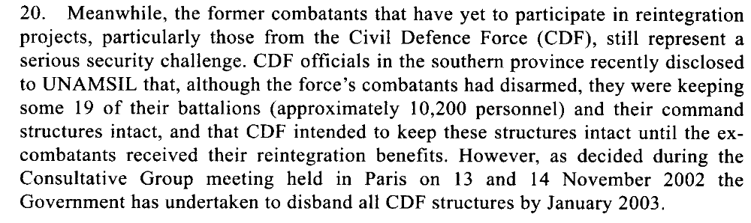
20. A total of 6,490 former combatants have so far
completed the reintegration process, and an additional
20,628 are currently participating in reintegration
projects in the agricultural sector, as well as in
vocational training, formal education and small
enterprises. Of these, 566 are in child-reintegration
projects. Under the current plans, it is envisaged that
up to 7,000 ex-combatants will be recruited for
reintegration projects every six months. However, the
programme is still plagued by a shortfall of $13.4
million in funding, as well as limited opportunities and
administrative shortcomings on the part of the National
Commission for Disarmament, Demobilization and
Reintegration. The ex-combatants awaiting reintegration
opportunities represent a potential threat to stability. As
indicated earlier, some of the ex-combatants have held
demonstrations in several parts of the country,
protesting non-payment of allowances.
21. UNAMSIL, UNDP and the Governments of the
United Kingdom, the United States and Japan are
supporting stopgap projects to occupy some of the excombatants
until long-term reintegration opportunities
are available. In the coming months, a total of 33 such
projects are expected to provide short-term support to
some 2,000 ex-combatants. In addition to implementing
these projects, UNAMSIL will continue to advise the
National Commission for Disarmament, Demobilization
and Reintegration on how to overcome its operational
shortcomings, as well as encourage it to ensure a
balanced geographical spread of reintegration
opportunities. The Mission will also monitor excombatants,
most of whom still live together as groups
in potentially volatile areas such as Tonkolili, Kono,
Kailahun and Kenema districts.

Assessment

Short-term compliance
No or marginal compliance (1) | x Medium low compliance (2) | Medium high compliance (3) | Full or almost full compliance (4)

Considerations underlying the assessment

There is evidence that efforts were being made to address the needs of former combatants but it is clear that there remained a serious lack of funding for the DDR program within this time frame.

Medium-term compliance

Description of the addressee(s)’ conduct

19. In the meantime, the Government of Sierra Leone, with the assistance of the
World Bank, is making arrangements to conduct an assessment of the effectiveness
of the overall disarmament, demobilization and reintegration programme. In this
connection, it should be noted that the main objective of the just-completed
programme in Sierra Leone was to provide ex-combatants with some skills through
very short-term training, as well as tools and a minimum amount of financial
resources to enable them to start a new life in civilian communities. As such, the
disarmament, demobilization and reintegration programme contributed immensely
to the stabilization of the country in the immediate aftermath of the war. However,
long-term community reintegration of the ex-combatants will depend on
employment opportunities, which must come from sustained economic growth.
20. It is also generally acknowledged that women combatants did not adequately
benefit from the disarmament, demobilization and reintegration programme,
particularly because the fast-tracking of the cantonment period resulted in a loss of
focus on special programmes intended for women.

Assessment

Medium-term compliance
No or marginal compliance (1) | Medium low compliance (2) | x Medium high compliance (3) | Full or almost full compliance (4)

Considerations underlying the assessment

The DDR program was completed within 2 years of this demand being issued. There remained some concerns about the effectiveness of the program and long term reintegration issues.

Depth of demand

Assessment

Level of depth of demand
Low depth of demand (1) | x Medium depth of demand (2) | High depth of demand (3)

Considerations underlying the assessment
Although it was in the interests of the Government to comply with this demand, raising funds for the DDR program proved challenging, particularly for the longer-term reintegration phase.

Level of confidence about coding decisions

Level of confidence about coding decision
Extremely high | x High | Moderate

Comments to IPI (if any)

Civil war in Sierra Leone

UNSC Resolution: | 1400
Date of adoption: | 28 March 2002
Operative paragraph: | 7
Demand number: | 2

Megan MacKenzie

Wording of demand

accelerate the restoration of civil authority and public services throughout the country, in particular in the diamond mining areas, including the deployment of key government personnel and police and the deployment of the Sierra Leone Army on border security tasks

List of addressees of the demand

Government of Sierra Leone

Short-term compliance

Description of the addressee(s)’ conduct

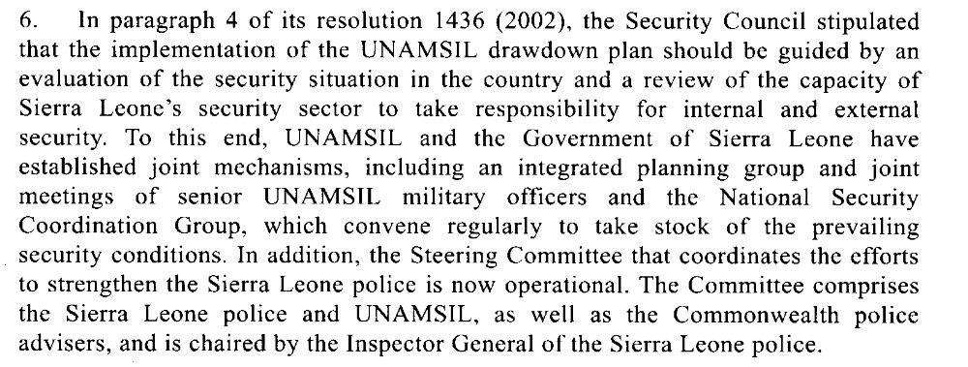
22. The restoration of effective local government
structures remains vital to the stabilization of the many
areas that were not controlled by the Government
during the conflict. Since the completion of the
disarmament process in January, UNAMSIL, UNDP
and international partners have facilitated the
deployment of Government administrators and the
police in all districts. Most paramount chiefs have also
returned to their chiefdoms. However, there are serious
capacity constraints, especially in the newly accessible
areas, that will require major investments in staffing,
training and equipment over several years.

Assessment

Short-term compliance
No or marginal compliance (1) | Medium low compliance (2) | x Medium high compliance (3) | Full or almost full compliance (4)

Considerations underlying the assessment
Clear steps had been taken by the Government to extend its authority and to build its governance capacity.

Medium-term compliance

Description of the addressee(s)’ conduct

While UNASMIL has been pulling out as planned,
concerns have grown that the government will not
meet the benchmarks, especially on police and
diamond mining.

As of July 2003, the police in particular were
finding it difficult to meet the benchmarks of the
withdrawal process. They are under-equipped,
under-staffed, and under-trained, and their
deployment in many parts of the country is in such
small numbers as to be more ceremonial than
practical.
The military (RSLAF) is faring better [than the police],
even though it is also short on equipment, housing
and training. Its performance in response to border
incursions occasioned by the Liberian civil war has
been erratic and at times unreliable.

Assessment

Medium-term compliance
No or marginal compliance (1) | x Medium low compliance (2) | Medium high compliance (3) | Full or almost full compliance (4)

Considerations underlying the assessment

In the period of time immediately after this demand was issued it seemed as if the Government was making major strides in its capacity. Over the long term it failed to meet this demand, particularly as a result of the weak police force.

Depth of demand

Assessment

Level of depth of demand
Low depth of demand (1) | x Medium depth of demand (2) | High depth of demand (3)

Considerations underlying the assessment
Extending the authority of the Government and building its capacity required significant mobilization and resources, particularly the recruitment and training of police officers.

Level of confidence about coding decisions

Level of confidence about coding decision
Extremely high | x High | Moderate

Comments to IPI (if any)

Civil war in Sierra Leone

UNSC Resolution: | 1400
Date of adoption: | 28 March 2002
Operative paragraph: | 11
Demand number: | 1

Megan MacKenzie

Wording of demand

continue dialogue and implement their commitments to building regional peace and security

List of addressees of the demand

Government of Sierra Leone

Short-term compliance

Description of the addressee(s)’ conduct

25. The actions and policies of the newly elected
Government will be crucial to the efforts to consolidate
the peace and sustain stability. In particular, it is vital
for the Government to maintain a culture of tolerance
that allows continued peaceful political competition. In
this connection, it may be recalled that one of the
principal objectives of the Sierra Leone peace process
was to integrate RUF into the political mainstream. In
the light of RUFP’s failure in the elections, a major
challenge for the Government will be to find ways of
keeping that party engaged in the democratic process.
UNAMSIL will therefore continue to encourage the
inclusion in the political process of not only RUFP, but
also other minority parties. To this end, my Special
Representative intends to facilitate the continuation of
the healthy political dialogue that was a key factor in
reaching national consensus on elections. It is also
important for both the Government and the international
community to continue to encourage the RUFP
leadership to continue to develop their political party.

Assessment

Short-term compliance
No or marginal compliance (1) | Medium low compliance (2) | x Medium high compliance (3) | Full or almost full compliance (4)

Considerations underlying the assessment

The Secretary General’s report specifically mentions the Government’s success in facilitating dialogue and working towards peace.

Medium-term compliance

Description of the addressee(s)’ conduct

47. Discussions with representatives of Sierra Leonean civil society and opposition
political parties left the assessment team with the impression that the Government
and its partners need to do more to sensitize the public in regard to the significant
progress made towards consolidating stability, laying the foundations of good
governance and promoting economic and social recovery as described above. This
important progress is being increasingly overshadowed by the perception among
many Sierra Leoneans that the political class may be reverting to its old self-serving
ways and that the root causes of the conflict are not being adequately addressed.
Citing many concerns, including high poverty levels, the political and economic
marginalization of certain segments of society, widespread unemployment and other
economic difficulties, a number of Sierra Leonean and international stakeholders felt
that the current political and economic situation in the country very much resembles
that which existed on the eve of the outbreak of the conflict in 1991. Needless to
say, a return to the status quo ante would sow the seeds of renewed instability.

Assessment

Medium-term compliance
No or marginal compliance (1) | Medium low compliance (2) | x Medium high compliance (3) | Full or almost full compliance (4)

Considerations underlying the assessment
There remained some concerns within the country related to peace and stability; however it is clear that dialogue was being encouraged and facilitated.

Depth of demand

Assessment

Level of depth of demand
x Low depth of demand (1) | Medium depth of demand (2) | High depth of demand (3)

Considerations underlying the assessment

Level of confidence about coding decisions

Level of confidence about coding decision
Extremely high | High | x Moderate

Comments to IPI (if any)

Civil war in Sierra Leone

UNSC Resolution: | 1400
Date of adoption: | 28 March 2002
Operative paragraph: | 14
Demand number: | 1

Megan MacKenzie

Wording of demand
take the necessary measures to bring to justice their own nationals responsible for such crimes

List of addressees of the demand

Government of Sierra Leone

Short-term compliance

Description of the addressee(s)’ conduct

24. A particular challenge will be to address the longstanding
problems of the judicial system in Sierra
Leone. This will require a comprehensive and sustained
effort on the part of the Government, with the support
of the international community, towards the rebuilding
of an impartial, transparent and independent judiciary.
The Government has appointed chairmen for all local
courts as well as justices of the peace, who would
handle minor civil and criminal cases. However, only 5
of the 14 magistrate courts in the country are currently
functioning, albeit with very limited capacity in terms
of trained personnel and logistics. UNAMSIL, UNDP
and the Government of the United Kingdom are now
coordinating their efforts to facilitate the early
extension of judicial coverage through the provision of
logistical support and the immediate rehabilitation of
key infrastructures.

Assessment

Short-term compliance
No or marginal compliance (1) | x Medium low compliance (2) | Medium high compliance (3) | Full or almost full compliance (4)

Considerations underlying the assessment
Efforts had been made to comply with this demand but there were clear shortcomings to the implementation of justice mechanisms at this time.

Medium-term compliance

Description of the addressee(s)’ conduct

23. Magistrate courts have been rehabilitated in all districts, and they are now
sitting in the district and provincial headquarters, albeit with inadequate coverage.
The recruitment of judges and magistrates has been hampered by the existing
unattractive conditions of service. There are only five magistrates assigned to
service a total of 12 districts. As a temporary measure, justices of the peace have
been trained, with the support of UNDP, and deployed to some 18 locations where
they perform judicial functions under the supervision of those magistrates.
24. Considering that only two years ago the extent of State authority was limited
to about one third of the country, the progress made in re-establishing government
administrative, security and judicial structures throughout the country is remarkable.
Nonetheless, the capacity of those structures to function effectively remains severely
limited due to the lack of logistics, infrastructure and qualified personnel.

Assessment

Medium-term compliance
No or marginal compliance (1) | Medium low compliance (2) | x Medium high compliance (3) | Full or almost full compliance (4)

Considerations underlying the assessment

Justice mechanisms were established within this time frame but they remained weak and subject to criticism.

Depth of demand

Assessment

Level of depth of demand
x Low depth of demand (1) | Medium depth of demand (2) | High depth of demand (3)

Considerations underlying the assessment

Level of confidence about coding decisions

Level of confidence about coding decision
Extremely high | x High | Moderate

Comments to IPI (if any)

Civil war in Sierra Leone

UNSC Resolution: | 1400
Date of adoption: | 28 March 2002
Operative paragraph: | 15
Demand number: | 1

Megan MacKenzie

Wording of demand

continue to cooperate to this end to fulfil their commitments under the Abuja Ceasefire Agreement

List of addressees of the demand
Government of Sierra Leone, Revolutionary United Front

Short-term compliance

Description of the addressee(s)’ conduct

11. The overall security situation in Sierra Leone has
remained generally stable in the wake of the elections.
However, continuing protests by ex-combatants, who
are dissatisfied with the late payment of their
allowances, have created tension in some areas. Civil
Defence Forces combatants demanding certain benefits
from the Government have also caused disturbances,
particularly in Moyamba. In addition, friction between
returning populations and ex-combatants, involving
disputes over illegally occupied houses, and relations
between former RUF combatants and their erstwhile
comrades who have joined the ruling party, have been a
source of tension in the volatile Tongo and Kailahun
areas. UNAMSIL troops have provided support to the
Sierra Leone police in containing disturbances, while
military observers and civil affairs officers have
mediated in disputes over illegally occupied houses.
12. Some political parties have complained to
UNAMSIL about harassment by supporters of the
ruling party. Although these reports could not be
verified, UNAMSIL has expressed concern to the
Government that such acts could be a source of
destabilization.
38. The successful holding of the elections on 14
May marked an important milestone in the Sierra
Leone peace process. Coming only four months after
the completion of the disarmament process, the
elections represent a remarkable step towards lasting
peace in Sierra Leone. I wish to congratulate the people
of Sierra Leone for turning out to vote in impressive
numbers, and in a peaceful and orderly manner. The
efforts of the National Electoral Commission, which
organized and conducted the elections, as well as
UNAMSIL and other international partners, which
provided vital security, logistical, technical and
financial support, should also be applauded.

Assessment

Short-term compliance
No or marginal compliance (1) | Medium low compliance (2) | x Medium high compliance (3) | Full or almost full compliance (4)

Considerations underlying the assessment

Within this time frame the major elements of the Abuja Peace Agreement had been established. The disarmament process had been finalized and relative security had held in the country.

Medium-term compliance

Description of the addressee(s)’ conduct

4. The Government of Sierra Leone, with the support of UNAMSIL and other
bilateral and multilateral partners, has made significant progress in meeting some
aspects of the benchmarks identified in my report to the Security Council of 5
September 2002 (S/2002/987). However, in many areas the progress made remains
fragile, and some major gaps still remain, particularly with regard to the security
sector. Much also remains to be done in the areas of consolidating State
administration throughout the country and restoring government control over
diamond-mining activities, as indicated in subsections 1 to 5 below.

Assessment

Medium-term compliance
No or marginal compliance (1) | Medium low compliance (2) | x Medium high compliance (3) | Full or almost full compliance (4)

Considerations underlying the assessment
Despite some lingering concerns regarding security and the reintegration process, peace was well established during this period of time.

Depth of demand

Assessment

Level of depth of demand
x Low depth of demand (1) | Medium depth of demand (2) | High depth of demand (3)

Considerations underlying the assessment

Level of confidence about coding decisions

Level of confidence about coding decision
Extremely high | High | Moderate

Comments to IPI (if any)

Civil war in Sierra Leone

UNSC Resolution: | 1436
Date of adoption: | 24 September 2002
Operative paragraph: | 5
Demand number: | 2

Megan MacKenzie

Wording of demand
seek actively the urgently needed additional resources for reintegration

List of addressees of the demand

Government of Sierra Leone

Short-term compliance

Description of the addressee(s)’ conduct
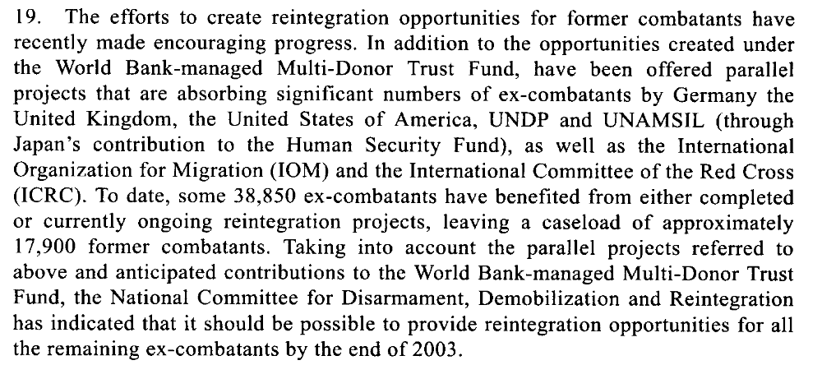

Assessment

Short-term compliance
No or marginal compliance (1) | Medium low compliance (2) | x Medium high compliance (3) | Full or almost full compliance (4)

Considerations underlying the assessment

The Secretary General’s report does not directly address funding but it is clear from the report that the Secretary General is pleased with the progress of the reintegration process and the manner in which the Government has been addressing reintegration.

Medium-term compliance

Description of the addressee(s)’ conduct

19. In the meantime, the Government of Sierra Leone, with the assistance of the
World Bank, is making arrangements to conduct an assessment of the effectiveness
of the overall disarmament, demobilization and reintegration programme. In this
connection, it should be noted that the main objective of the just-completed
programme in Sierra Leone was to provide ex-combatants with some skills through
very short-term training, as well as tools and a minimum amount of financial
resources to enable them to start a new life in civilian communities. As such, the
disarmament, demobilization and reintegration programme contributed immensely
to the stabilization of the country in the immediate aftermath of the war. However,
long-term community reintegration of the ex-combatants will depend on
employment opportunities, which must come from sustained economic growth.
20. It is also generally acknowledged that women combatants did not adequately
benefit from the disarmament, demobilization and reintegration programme,
particularly because the fast-tracking of the cantonment period resulted in a loss of
focus on special programmes intended for women.

Assessment

Medium-term compliance
No or marginal compliance (1) | Medium low compliance (2) | x Medium high compliance (3) | Full or almost full compliance (4)

Considerations underlying the assessment

It is clear from this report and from other sources that the reintegration process in Sierra Leone was not perfect; however, it was completed within this time frame with relative success.

Depth of demand

Assessment

Level of depth of demand
x Low depth of demand (1) | Medium depth of demand (2) | High depth of demand (3)

Considerations underlying the assessment
It was in the interests of the Government of Sierra Leone to find more resources for the reintegration process. Furthermore, the Government had support and encouragement from multiple international sources at this time.

Level of confidence about coding decisions

Level of confidence about coding decision
Extremely high | x High | Moderate

Comments to IPI (if any)

Civil war in Sierra Leone

UNSC Resolution: | 1436
Date of adoption: | 24 September 2002
Operative paragraph: | 7
Demand number: | 1

Megan MacKenzie

Wording of demand
accelerate the consolidation of civil authority and public services throughout the country, and strengthen the operational effectiveness of the security sector

List of addressees of the demand

Government of Sierra Leone

Short-term compliance

Description of the addressee(s)’ conduct
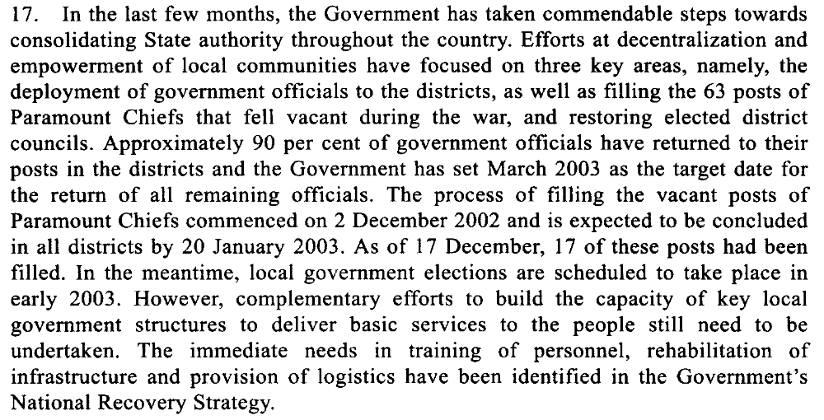

Assessment

Short-term compliance
No or marginal compliance (1) | Medium low compliance (2) | x Medium high compliance (3) | Full or almost full compliance (4)

Considerations underlying the assessment
The Secretary-General’s report specifically mentions that the Government has achieved major gains in relation to its authority in the country. It is mentioned that there are still several areas that the Government must work on; however, overall it appears that the Government has complied with this demand.

Medium-term compliance

Description of the addressee(s)’ conduct

22. Government officials from the relevant line ministries have been deployed in
all 12 administrative districts of the country, and paramount chiefs have returned to
their chiefdoms. The 64 paramount chief posts that fell vacant during the conflict
were filled through elections held from 2 December 2002 to 24 January 2003. The
presence of a better-equipped and more disciplined national police force is now
visible in the provinces and, as indicated earlier, district and provincial security
committees are being set up throughout the country.
23. Magistrate courts have been rehabilitated in all districts, and they are now
sitting in the district and provincial headquarters, albeit with inadequate coverage.
The recruitment of judges and magistrates has been hampered by the existing
unattractive conditions of service. There are only five magistrates assigned to
service a total of 12 districts. As a temporary measure, justices of the peace have
been trained, with the support of UNDP, and deployed to some 18 locations where
they perform judicial functions under the supervision of those magistrates.
24. Considering that only two years ago the extent of State authority was limited
to about one third of the country, the progress made in re-establishing government
administrative, security and judicial structures throughout the country is remarkable.
Nonetheless, the capacity of those structures to function effectively remains severely
limited due to the lack of logistics, infrastructure and qualified personnel. There is
also concern that the district councils expected to be elected in May will likely face
similar constraints, which could render ineffectual the efforts to decentralize the
functions of the central Government. However, the World Bank, the Department for
International Development, UNDP, the European Union and the United States
Agency for International Development have indicated that they would provide
capacity-building support to the councils and to the decentralization process in
general.

Assessment

Medium-term compliance
No or marginal compliance (1) | Medium low compliance (2) | x Medium high compliance (3) | Full or almost full compliance (4)

Considerations underlying the assessment
There remained some concerns regarding state authority- particularly in terms of logistical support and its long-term capacity- however, the Government of Sierra Leone achieved major successes in terms of extending its authority within this time frame.

Depth of demand

Assessment

Level of depth of demand
x Low depth of demand (1) | Medium depth of demand (2) | High depth of demand (3)

Considerations underlying the assessment
It was in the Government’s interests to continue to extend its authority and did not require them to alter their behavior significantly.

Level of confidence about coding decisions

Level of confidence about coding decision
Extremely high | x High | Moderate

Comments to IPI (if any)

Civil war in Sierra Leone

UNSC Resolution: | 1400
Date of adoption: | 28 March 2002
Operative paragraph: | 8
Demand number: | 1

Megan MacKenzie

Wording of demand

set out and implement urgently a policy to regulate and control diamond mining activities

List of addressees of the demand
Government of Sierra Leone

Short-term compliance

Description of the addressee(s)’ conduct

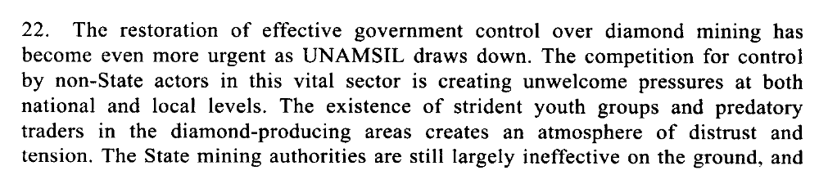
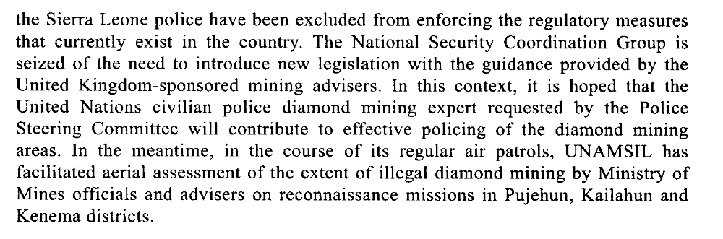

Assessment

Short-term compliance
No or marginal compliance (1) | x Medium low compliance (2) | Medium high compliance (3) | Full or almost full compliance (4)

Considerations underlying the assessment
It is clear that efforts had been made to extend Government authority in the diamond regions. Despite these efforts, there remained a high degree of lawlessness, corruption, and illicit activities in the diamond regions.

Medium-term compliance

Description of the addressee(s)’ conduct

25. The Government has taken important measures to reassert its control over
diamond mining. In December 2004, the Cabinet approved a new core minerals
policy that seeks to create an enabling legal, fiscal and institutional framework for
the development of the country’s mineral wealth and prevent the use of natural
resources to finance conflict and other illegal activities. Specific steps taken by the
Government in this context include the establishment of a diamond crime,
intelligence and investigation unit within the Sierra Leone police; vigorous law
enforcement measures, including the deployment of mine monitors and wardens in
mining areas; and incentives, such as the establishment of the Diamond Areas
Community Development Fund, to encourage legal mining.
26. Furthermore, the 1994 Minerals Act has been amended to ensure stricter
penalties for the illegal possession and smuggling of diamonds. In addition,
UNAMSIL, jointly with the officials of the Ministry of Mineral Resources and the
Sierra Leone police, conducted aerial surveys and ground patrols of mining areas
throughout the country. The High-level Steering Committee on Diamonds also
continues to coordinate efforts aimed at improving the governance and development
of the diamond sector. As a result of these and other measures, the number of
diamond-mining licences issued rose from 900 in June 2002 to 2,091 by the end of
2003, while official diamond exports increased from $10 million in 2000 to $76
million in 2003.
27. Nonetheless, the diamond sector still faces many serious challenges. More than
50 per cent of diamond-mining activities in the country remain unlicensed. In
addition, diamond-mining rights and boundaries continue to be a major source of
disputes among chiefdoms, and the large numbers of youths engaged in mining
activities, as well as the largely unregulated power of chiefdom authorities to issue
mining licences, present obstacles for potential investors. The use of child labour in
the mines also continues to pose a serious challenge for Sierra Leone, despite the
new policy prohibiting this practice.
28. The increase in legal mining activities, in particular the recent resumption of
kimberlite mining in Koidu, is expected to have a positive impact on the country’s
economy. However, the concerns expressed by many Sierra Leoneans about the
environmental impact of the kimberlite mining, as well as alluvial mining, should be
seriously addressed by the Government. In addition, it should be emphasized that
bringing diamond mining under effective control is a long-term effort that will also
require active community involvement and international support.

Assessment

Medium-term compliance
No or marginal compliance (1) | Medium low compliance (2) | x Medium high compliance (3) | Full or almost full compliance (4)

Considerations underlying the assessment
It is evident from this report that the Government had made more obvious gains in this area. The report mentions specific steps the Government took to extend its authority in the diamond regions and to regulate the sales of diamonds, including
the establishment of a diamond crime, intelligence and investigation unit within the Sierra Leone police; vigorous law enforcement measures, including the deployment of mine monitors and wardens in mining areas.

Depth of demand

Assessment

Level of depth of demand
x Low depth of demand (1) | Medium depth of demand (2) | High depth of demand (3)

Considerations underlying the assessment
Gaining control of the diamond region and regulating the sales of diamonds was in the interests of the Government for security reasons as well as for revenue purposes.

Level of confidence about coding decisions

Level of confidence about coding decision
Extremely high | High | Moderate

Comments to IPI (if any)

United Nations Secretary-General. Fourteenth report of the Secretary-General on the United Nations Mission in Sierra Leone. 19 June 2002
United Nations Secretary-General. Twenty-first report of the Secretary-General on the United Nations Mission in Sierra Leone. 19 March 2004.
United Nations Secretary-General. Fourteenth report of the Secretary-General on the United Nations Mission in Sierra Leone. 19 June 2002
United Nations Secretary-General. Twenty-first report of the Secretary-General on the United Nations Mission in Sierra Leone. 19 March 2004.
United Nations Secretary-General. Fourteenth report of the Secretary-General on the United Nations Mission in Sierra Leone. 19 June 2002
International Crisis Group. Sierra Leone: The State of Security and Governance. ICG Africa Report No 67. Freetown/London/Brussels. 3 September 2003. P15
United Nations Secretary-General. Fourteenth report of the Secretary-General on the United Nations Mission in Sierra Leone. 19 June 2002
United Nations Secretary-General. Twenty-first report of the Secretary-General on the United Nations Mission in Sierra Leone. 19 March 2004.
United Nations Secretary-General. Fourteenth report of the Secretary-General on the United Nations Mission in Sierra Leone. 19 June 2002
International Crisis Group. Sierra Leone: The State of Security and Governance. ICG Africa Report No 67. Freetown/London/Brussels. 3 September 2003. P5.
International Crisis Group. Sierra Leone: The State of Security and Governance. ICG Africa Report No 67. Freetown/London/Brussels. 3 September 2003. P5.
United Nations Secretary-General. Fourteenth report of the Secretary-General on the United Nations Mission in Sierra Leone. 19 June 2002
United Nations Secretary-General. Twenty-first report of the Secretary-General on the United Nations Mission in Sierra Leone. 19 March 2004.
United Nations Secretary-General. Fourteenth report of the Secretary-General on the United Nations Mission in Sierra Leone. 19 June 2002
United Nations Secretary-General. Twenty-first report of the Secretary-General on the United Nations Mission in Sierra Leone. 19 March 2004.
United Nations Secretary-General. Fourteenth report of the Secretary-General on the United Nations Mission in Sierra Leone. 19 June 2002
United Nations Secretary-General. Twenty-first report of the Secretary-General on the United Nations Mission in Sierra Leone. 19 March 2004.
United Nations Secretary-General. Sixteenth report of the Secretary General on the United Nations Mission in Sierra Leone 24 December 2002.
United Nations Secretary-General. Twenty-first report of the Secretary-General on the United Nations Mission in Sierra Leone. 19 March 2004.
United Nations Secretary-General. Sixteenth report of the Secretary General on the United Nations Mission in Sierra Leone 24 December 2002.
United Nations Secretary-General. Twenty-first report of the Secretary-General on the United Nations Mission in Sierra Leone. 19 March 2004.
United Nations Secretary-General. Sixteenth report of the Secretary General on the United Nations Mission in Sierra Leone 24 December 2002.
United Nations Secretary-General. Twenty-first report of the Secretary-General on the United Nations Mission in Sierra Leone. 19 March 2004.
United Nations Security Council, Reintegration of ex-combatants, Sixteenth Report of the Secretary-General on the United Nations Mission in Sierra Leone. (S/2002/1417, 24 December 2002), pp.6.
United Nations Security Council, 'Strengthening the Security Sector', Sixteenth Report of the Secretary-General on the United Nations Mission in Sierra Leone (S/2002/1417, 24 December 2002) pp.2

